Airbnb Business Analysis: Predicting New York City Listing Prices
with Deep Learning
Group B
Machine Learning (ML_PCOM7E) — Track 2: Deep Learning
Development Team Project

Introduction
Without owning a single property, Airbnb has expanded from a little room-sharing startup to become one of the biggest lodging platforms globally. Thousands of listings vie for the same visitors in a city like New York, but hosts never have trustworthy advice on how to set their prices: if they charge too much, guests will look elsewhere; if they charge too little, they will lose money. This problem has broader strategic ramifications because Airbnb's expansion has put quantifiable pressure on conventional hotel markets in crowded cities (Zervas, Proserpio, and Byers, 2017), and the factors influencing listing prices are now a hot topic of research (Wang and Nicolau, 2017; Guttentag, 2015). "Can a neural network predict NYC Airbnb listing prices more accurately than classical regression, and which listing features drive its predictions?" is the subject this study explores. Airbnb's executive decision-making is taken into consideration throughout the investigation.

Approach and Techniques
The study proceeds from requirements through data and modeling to serving, following the structured workflow of the ML Design Template (no date) utilized in the module (Figure 1). While a feed-forward neural network embodies the deep-learning strategy needed for Track 2, a standard linear regression offers an interpretable baseline. Neural networks are suitable in this situation because, in contrast to linear regression, they can simultaneously capture complex, non-linear interactions among numerous variables (LeCun, Bengio, and Hinton, 2015). Additionally, they eliminate the need for manual feature selection by providing the entire feature set and allowing the network to directly learn pertinent structure (Alzubaidi et al., 2021). Both a two-layer (128–64 units) and a three-layer (128–64–32 units) architecture were examined utilizing batch normalization, ReLU activations, and dropout, and trained with the Adam optimizer because depth is a crucial design decision. Scalability and deployment are outside the purview of this academic project, which lacks substantial hardware; instead, the focus is on comprehension and experimentation rather than a deployable system.
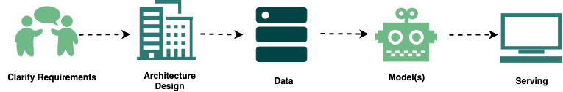
Figure 1: The machine-learning workflow followed in this study (after ML Design Template, no date).

Data and Preparation
The dataset's 48,895 listings each have sixteen attributes spanning host information, location, room type, price, availability and review activity. As price is the target variable, no further labelling was needed. Before modelling, identifier and free-text fields (id, name, host_id, host_name, last_review) were dropped as irrelevant to price, and 11 zero-price listings were removed as obvious errors (Figure 2). Remaining features were standardised, categorical variables one-hot encoded, and missing review-rate values set to zero. The data were split 80% for training and 20% for unseen testing. Three metrics were used: the coefficient of determination (R²), the share of price variance explained; root mean squared error (RMSE), which penalises large errors more heavily; and mean absolute error (MAE), the average error in dollars.
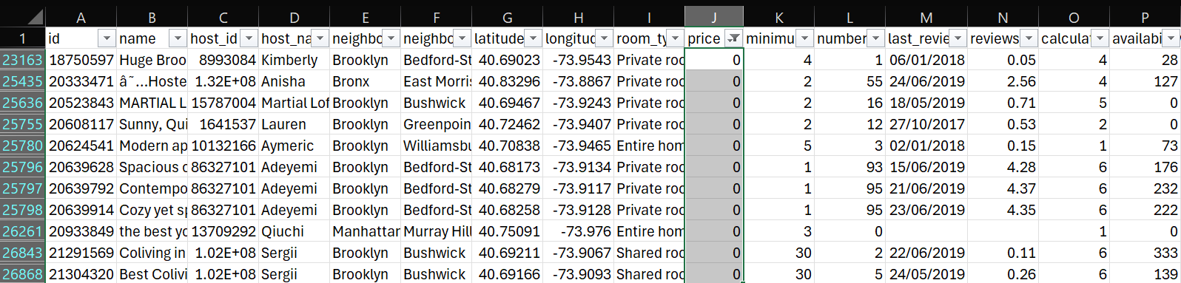
Figure 2: Sample of removed records — listings with a price of zero, identified as data-entry errors.

Findings
Greater depth did not enhance generalization, according to a comparison of the two neural networks on the unseen test set. On training data, the three-layer model had a better R² (0.34) than the two-layer model (0.19), but this collapsed on test data, when its RMSE increased to 232.7 and its R² dropped to 0.07 compared to the two-layer model's 0.14 (Table 1). In line with findings that deeper networks do not always outperform simpler models on tabular data, this growing train-test gap is a classic indication of overfitting (Grinsztajn, Oyallon, and Varoquaux, 2022). For this reason, the two-layer network was chosen.
Metric (test set) | 2-Layer NN | 3-Layer NN | Linear Reg.
MAE (lower is better) | 67.4 | 64.6 | 72.7
RMSE (lower is better) | 224.6 | 232.7 | 228.0
R² (higher is better) | 0.14 | 0.07 | 0.11
Table 1: Model performance on the unseen test set; the best result for each metric is shown in bold.
Permutation importance was used to determine which features influence its predictions: each feature was shuffled at random in turn, and the rise in error was noted (Breiman, 2001). The most significant factors were room type, availability, and neighborhood (Table 2, Figure 3), which is in line with the idea that lodging costs are determined by property and location (Zhang et al., 2017). For a like-for-like comparison, a linear regression baseline was constructed using these three characteristics. The neural network performed better on the test set in all metrics, including lower MAE (67.4 vs. 72.7), lower RMSE (224.6 vs. 228.0), and greater R² (0.14 vs. 0.11).
Rank | Feature | RMSE increase when shuffled
1 | Room type | 17
2 | Availability (365 days) | 10
3 | Neighbourhood | 8
Table 2: Feature impact, measured by the rise in RMSE when each feature is randomly shuffled (permutation importance) on the two-layer model.
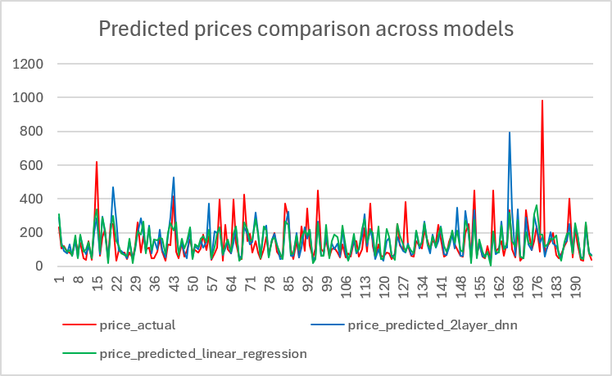
Figure 3: Comparison of predicted price across models.
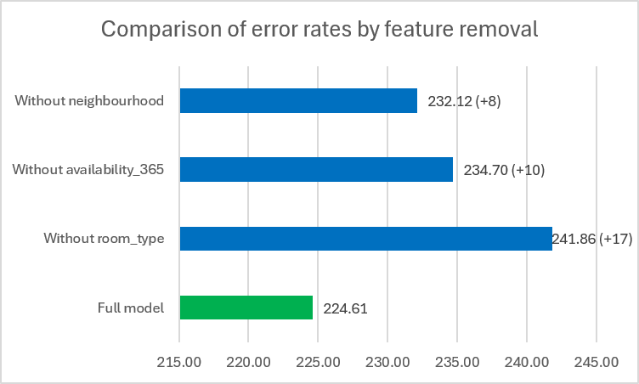
Figure 4: Comparison of error rates with the 2-layer neural network model across the most influential price drivers.

Discussion
The findings have two useful implications for Airbnb. First, the employment of neural networks in host-facing pricing tools is supported by their superior ability to predict listing prices compared to classical regression. Second, the main factors influencing price are room type, availability, and location; these factors might influence market segmentation and host recommendations (Wang and Nicolau, 2017). Be cautious when interpreting these results. The majority of price variance cannot be predicted by structural features alone; richer signals like listing text, photos, and seasonality would probably increase accuracy (Kalehbasti, Nikolenko, and Rezaei, 2021; Chen et al., 2024). The explanatory power of all models was limited, with R2 near 0.14. Neighborhoods with few listings can skew apparent trends, and the wide disparity between MAE and RMSE is caused by a few extremely expensive listings that exaggerate errors. Additionally, the comparison is purposefully constrained because the network's advantage is a fair but not exhaustive contest because the regression was not tuned. A cloud platform could serve the model in production, but it would need drift monitoring, retraining, and the previously mentioned richer features.

Conclusion
Across all metrics, a two-layer neural network outperformed a traditional regression in predicting NYC Airbnb prices; the greatest price drivers were room type, availability, and neighborhood. The analysis provides Airbnb with a clear, evidence-based understanding of what influences listing prices and a solid foundation for the more sophisticated, feature-rich pricing models a production tool would need, even though the overall explanatory power was small.

References
Alzubaidi, L. et al. (2021) ‘Review of deep learning: concepts, CNN architectures, challenges, applications, future directions’, Journal of Big Data, 8, 53. doi: 10.1186/s40537-021-00444-8.
Breiman, L. (2001) ‘Random forests’, Machine Learning, 45(1), pp. 5–32. doi: 10.1023/A:1010933404324.
Chen, Y. et al. (2024) ‘A sustainable rental price prediction model based on multimodal input and deep learning: evidence from Airbnb’, Sustainability, 16(15), 6384. doi: 10.3390/su16156384.
Grinsztajn, L., Oyallon, E. and Varoquaux, G. (2022) ‘Why do tree-based models still outperform deep learning on typical tabular data?’, Advances in Neural Information Processing Systems, 35, pp. 507–520. doi: 10.48550/arXiv.2207.08815.
Guttentag, D. (2015) ‘Airbnb: disruptive innovation and the rise of an informal tourism accommodation sector’, Current Issues in Tourism, 18(12), pp. 1192–1217. doi: 10.1080/13683500.2013.827159.
Kalehbasti, P.R., Nikolenko, L. and Rezaei, H. (2021) ‘Airbnb price prediction using machine learning and sentiment analysis’, in Machine Learning and Knowledge Extraction (CD-MAKE 2021). Cham: Springer, pp. 173–184. doi: 10.1007/978-3-030-84060-0_11.
LeCun, Y., Bengio, Y. and Hinton, G. (2015) ‘Deep learning’, Nature, 521(7553), pp. 436–444. doi: 10.1038/nature14539.
ML Design Template — ML Interviews (no date). Available at: https://www.machinelearninginterviews.com/ml-design-template/ (Accessed: 23 May 2026).
Wang, D. and Nicolau, J.L. (2017) ‘Price determinants of sharing economy based accommodation rental: a study of listings from 33 cities on Airbnb.com’, International Journal of Hospitality Management, 62, pp. 120–131. doi: 10.1016/j.ijhm.2016.12.007.
Zervas, G., Proserpio, D. and Byers, J.W. (2017) ‘The rise of the sharing economy: estimating the impact of Airbnb on the hotel industry’, Journal of Marketing Research, 54(5), pp. 687–705. doi: 10.1509/jmr.15.0204.
Zhang, Z. et al. (2017) ‘Key factors affecting the price of Airbnb listings: a geographically weighted approach’, Sustainability, 9(9), 1635. doi: 10.3390/su9091635.
Supporting code and modelling outputs are available at github.com/mscaimh/deep_learning_ab_nyc_2019

